Zuhal Ahmadi

**Student Grading System**

This project is about an Android mobile application for the university student to check their final grades. The application gets the student ID#, course name, and the total marks as an input from the user then calculates the letter grade based on the AUAF grading schema.

1. **Project Design**

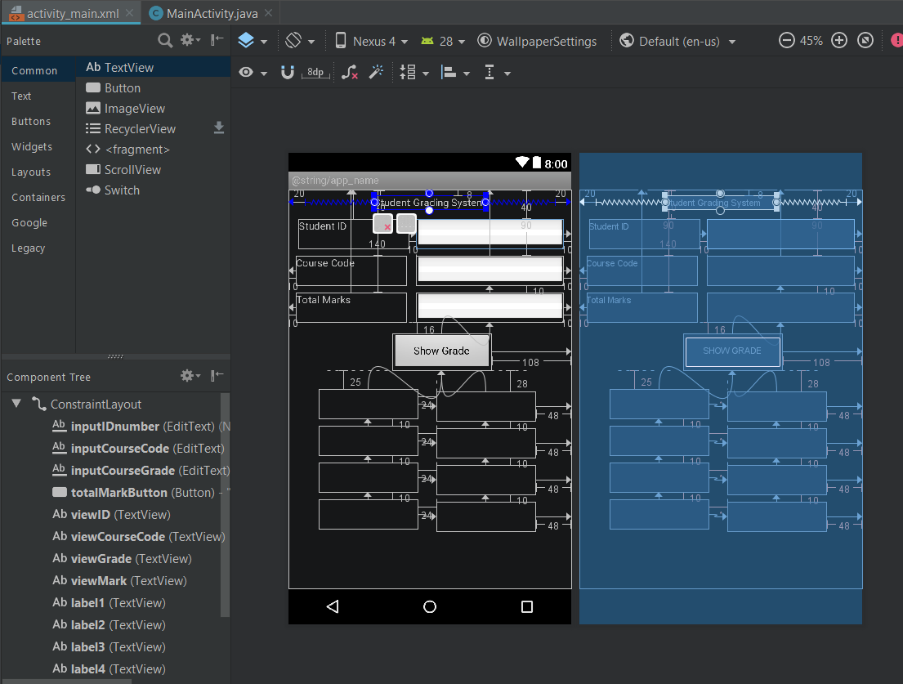

Figure 1.0 Design & Component Tree

1. **Project XML Code**
2. <?xml version="1.0" encoding="utf-8"?>  
   <android.support.constraint.ConstraintLayout xmlns:android="http://schemas.android.com/apk/res/android"  
    xmlns:app="http://schemas.android.com/apk/res-auto"  
    xmlns:tools="http://schemas.android.com/tools"  
    android:layout_width="match_parent"  
    android:layout_height="match_parent"  
    tools:context=".MainActivity">  
     
    <EditText  
    android:id="@+id/inputIDnumber"  
    android:layout_width="200dp"  
    android:layout_height="40dp"  
    android:layout_marginEnd="10dp"  
    android:layout_marginRight="10dp"  
    android:layout_marginTop="40dp"  
    android:inputType="number"  
    android:visibility="visible"  
    app:layout_constraintEnd_toEndOf="parent"  
    app:layout_constraintTop_toTopOf="parent" />  
     
    <EditText  
    android:id="@+id/inputCourseCode"  
    android:layout_width="200dp"  
    android:layout_height="40dp"  
    android:layout_marginEnd="10dp"  
    android:layout_marginRight="10dp"  
    android:layout_marginTop="90dp"  
    android:inputType="text"  
    android:textAllCaps="true"  
    android:visibility="visible"  
    app:layout_constraintEnd_toEndOf="parent"  
    app:layout_constraintTop_toTopOf="parent" />  
     
    <EditText  
    android:id="@+id/inputCourseGrade"  
    android:layout_width="200dp"  
    android:layout_height="40dp"  
    android:layout_marginEnd="10dp"  
    android:layout_marginRight="10dp"  
    android:layout_marginTop="10dp"  
    android:inputType="numberDecimal"  
    android:visibility="visible"  
    app:layout_constraintEnd_toEndOf="parent"  
    app:layout_constraintTop_toBottomOf="@+id/inputCourseCode" />  
     
    <Button  
    android:id="@+id/totalMarkButton"  
    android:layout_width="135dp"  
    android:layout_height="50dp"  
    android:layout_marginEnd="108dp"  
    android:layout_marginRight="108dp"  
    android:layout_marginTop="16dp"  
    android:text="Show Grade"  
    android:visibility="visible"  
    app:layout_constraintEnd_toEndOf="parent"  
    app:layout_constraintTop_toBottomOf="@+id/inputCourseGrade" />  
     
    <TextView  
    android:id="@+id/viewID"  
    android:layout_width="135dp"  
    android:layout_height="40dp"  
    android:layout_marginEnd="48dp"  
    android:layout_marginRight="48dp"  
    android:layout_marginTop="28dp"  
    android:visibility="visible"  
    app:layout_constraintEnd_toEndOf="parent"  
    app:layout_constraintTop_toBottomOf="@+id/totalMarkButton" />  
     
    <TextView  
    android:id="@+id/viewCourseCode"  
    android:layout_width="135dp"  
    android:layout_height="40dp"  
    android:layout_marginEnd="48dp"  
    android:layout_marginRight="48dp"  
    android:layout_marginTop="10dp"  
    android:ems="10"  
    android:visibility="visible"  
    app:layout_constraintEnd_toEndOf="parent"  
    app:layout_constraintTop_toBottomOf="@+id/viewID" />  
     
    <TextView  
    android:id="@+id/viewGrade"  
    android:layout_width="135dp"  
    android:layout_height="40dp"  
    android:layout_marginEnd="48dp"  
    android:layout_marginRight="48dp"  
    android:layout_marginTop="10dp"  
    android:visibility="visible"  
    app:layout_constraintEnd_toEndOf="parent"  
    app:layout_constraintTop_toBottomOf="@+id/viewCourseCode" />  
     
    <TextView  
    android:id="@+id/viewMark"  
    android:layout_width="135dp"  
    android:layout_height="40dp"  
    android:layout_marginEnd="48dp"  
    android:layout_marginRight="48dp"  
    android:layout_marginTop="10dp"  
    android:visibility="visible"  
    app:layout_constraintEnd_toEndOf="parent"  
    app:layout_constraintTop_toBottomOf="@+id/viewGrade" />  
     
    <TextView  
    android:id="@+id/label1"  
    android:layout_width="135dp"  
    android:layout_height="40dp"  
    android:layout_marginEnd="24dp"  
    android:layout_marginRight="24dp"  
    android:layout_marginTop="25dp"  
    android:visibility="visible"  
    app:layout_constraintEnd_toStartOf="@+id/viewID"  
    app:layout_constraintTop_toBottomOf="@+id/totalMarkButton" />  
     
    <TextView  
    android:id="@+id/label2"  
    android:layout_width="135dp"  
    android:layout_height="40dp"  
    android:layout_marginEnd="24dp"  
    android:layout_marginRight="24dp"  
    android:layout_marginTop="10dp"  
    android:visibility="visible"  
    app:layout_constraintEnd_toStartOf="@+id/viewCourseCode"  
    app:layout_constraintTop_toBottomOf="@+id/label1" />  
     
    <TextView  
    android:id="@+id/label3"  
    android:layout_width="135dp"  
    android:layout_height="40dp"  
    android:layout_marginEnd="24dp"  
    android:layout_marginRight="24dp"  
    android:layout_marginTop="10dp"  
    android:visibility="visible"  
    app:layout_constraintEnd_toStartOf="@+id/viewGrade"  
    app:layout_constraintTop_toBottomOf="@+id/label2" />  
     
    <TextView  
    android:id="@+id/label4"  
    android:layout_width="135dp"  
    android:layout_height="40dp"  
    android:layout_marginEnd="24dp"  
    android:layout_marginRight="24dp"  
    android:layout_marginTop="10dp"  
    android:visibility="visible"  
    app:layout_constraintEnd_toStartOf="@+id/viewMark"  
    app:layout_constraintTop_toBottomOf="@+id/label3" />  
     
    <TextView  
    android:id="@+id/textViewID"  
    android:layout_width="150dp"  
    android:layout_height="40dp"  
    android:layout_marginEnd="10dp"  
    android:layout_marginRight="10dp"  
    android:layout_marginTop="40dp"  
    android:text="Student ID"  
    android:visibility="visible"  
    app:layout_constraintEnd_toStartOf="@+id/inputIDnumber"  
    app:layout_constraintTop_toTopOf="parent" />  
     
    <TextView  
    android:id="@+id/textViewCC"  
    android:layout_width="150dp"  
    android:layout_height="40dp"  
    android:layout_marginLeft="10dp"  
    android:layout_marginStart="10dp"  
    android:layout_marginTop="90dp"  
    android:text="Course Code"  
    app:layout_constraintStart_toStartOf="parent"  
    app:layout_constraintTop_toTopOf="parent" />  
     
    <TextView  
    android:id="@+id/textViewGrade"  
    android:layout_width="150dp"  
    android:layout_height="40dp"  
    android:layout_marginLeft="10dp"  
    android:layout_marginStart="10dp"  
    android:layout_marginTop="140dp"  
    android:text="Total Marks"  
    app:layout_constraintStart_toStartOf="parent"  
    app:layout_constraintTop_toTopOf="parent" />  
     
    <TextView  
    android:id="@+id/textView2"  
    android:layout_width="wrap_content"  
    android:layout_height="wrap_content"  
    android:layout_marginEnd="20dp"  
    android:layout_marginLeft="20dp"  
    android:layout_marginRight="20dp"  
    android:layout_marginStart="20dp"  
    android:layout_marginTop="8dp"  
    android:text="Student Grading System"  
    app:layout_constraintEnd_toEndOf="parent"  
    app:layout_constraintStart_toStartOf="parent"  
    app:layout_constraintTop_toTopOf="parent" />  
     
   </android.support.constraint.ConstraintLayout>
3. **Project Java Code**
4. package com.example.zohaldanishahmadi.studentgradingsystem;  
     
    import android.support.v7.app.AppCompatActivity;  
    import android.os.Bundle;  
    import android.view.View;  
    import android.widget.Button;  
    import android.widget.EditText;  
    import android.widget.TextView;  
     
   public class MainActivity extends AppCompatActivity {  
     
    EditText stID = null;  
    EditText cCode = null;  
    EditText grade = null;  
     
    TextView viewID = null;  
    TextView viewCC = null;  
    TextView viewGrade = null;  
    TextView viewMark = null;  
    TextView viewID1 = null;  
    TextView viewCC1 = null;  
    TextView viewGrade1 = null;  
    TextView viewMark1 = null;  
     
    Button MarkButton = null;  
     
     
    @Override  
    protected void onCreate(Bundle savedInstanceState) {  
    super.onCreate(savedInstanceState);  
    setContentView(R.layout.*activity_main*);  
     
    stID = findViewById(R.id.*inputIDnumber*);  
    cCode = findViewById(R.id.*inputCourseCode*);  
    grade = findViewById(R.id.*inputCourseGrade*);  
     
    viewID = findViewById(R.id.*viewID*);  
    viewCC = findViewById(R.id.*viewCourseCode*);  
    viewGrade = findViewById(R.id.*viewGrade*);  
    viewMark = findViewById(R.id.*viewMark*);  
    viewID1 = findViewById(R.id.*label1*);  
    viewCC1 = findViewById(R.id.*label2*);  
    viewGrade1 = findViewById(R.id.*label3*);  
    viewMark1 = findViewById(R.id.*label4*);  
     
    MarkButton = findViewById(R.id.*totalMarkButton*);  
     
    MarkButton.setOnClickListener(new View.OnClickListener() {  
    @Override  
    public void onClick(View view) {  
    String id = stID.getText().toString();  
    int i = Integer.*parseInt*(id);  
    String courseC = cCode.getText().toString();  
    String courseG = grade.getText().toString();  
     
    double m = Double.*parseDouble*(courseG);  
     
     
    if (m <= 100 && m >= 94)  
    viewMark.setText("A");  
    else if (m <= 93 && m >= 90)  
    viewMark.setText("A-");  
    else if (m <= 89 && m >= 87)  
    viewMark.setText("B+");  
    else if (m <= 86 && m >= 84)  
    viewMark.setText("B");  
    else if (m <= 83 && m >= 80)  
    viewMark.setText("B-");  
    else if (m <= 79 && m >= 77)  
    viewMark.setText("C+");  
    else if (m <= 76 && m >= 74)  
    viewMark.setText("C");  
    else if (m <= 73 && m >= 70)  
    viewMark.setText("C-");  
    else if (m <= 69 && m >= 67)  
    viewMark.setText("D+");  
    else if (m <= 66 && m >= 60)  
    viewMark.setText("D");  
    else if (m <= 59)  
    viewMark.setText("F");  
    else  
    viewMark.setText("Entry is out of range!");  
     
     
    viewID.setText(id);  
    viewCC.setText(courseC.toUpperCase());  
    viewGrade.setText(courseG);  
    viewID1.setText("Student ID");  
    viewCC1.setText("Course Code");  
    viewMark1.setText("Total Marks");  
    viewGrade1.setText("Grade");  
     
     
     
    }  
    });  
     
    }  
   }
5. **Project Demo**

